WEEK 8

GIT

1. Git-HOL

**Added welcome.txt in Gitlab**

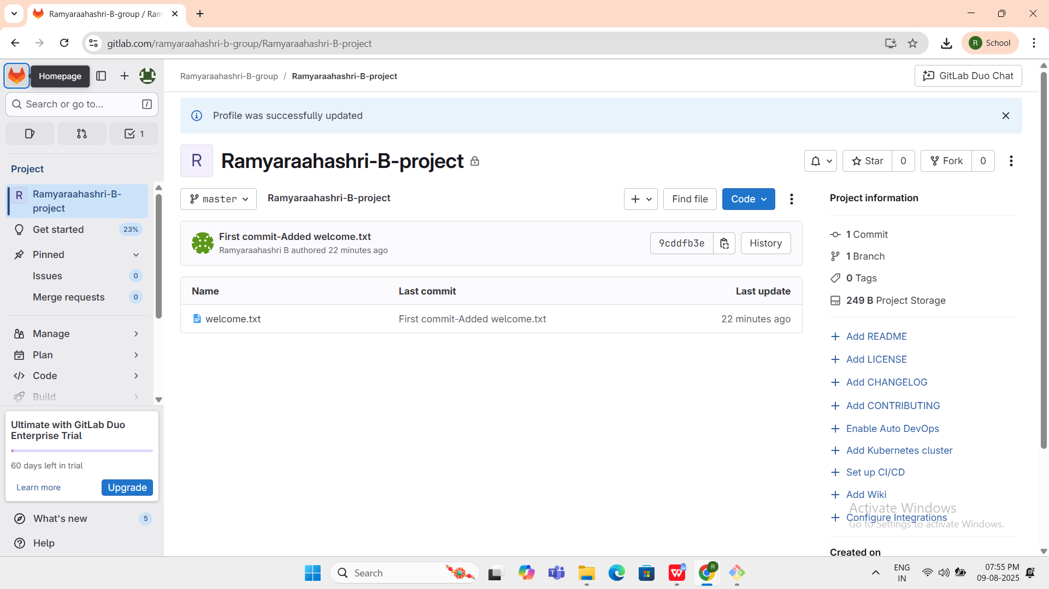

**OUTPUT:**

**welcome.txt**

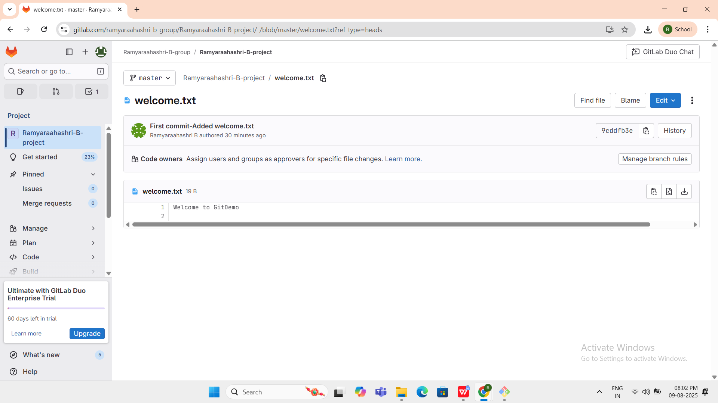

1. Git-HOL

**OUTPUT:**

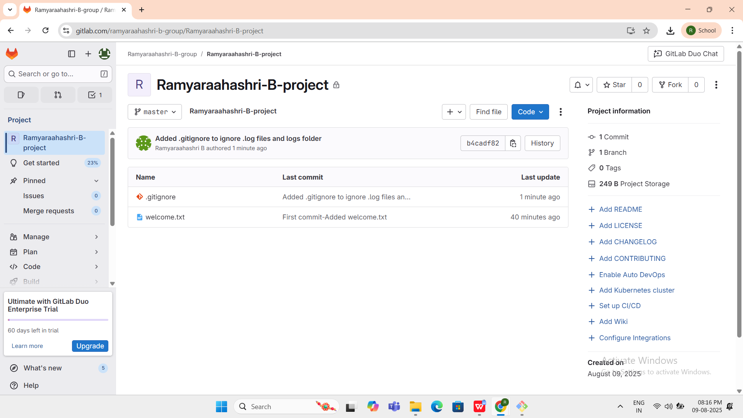

**.gitignore**

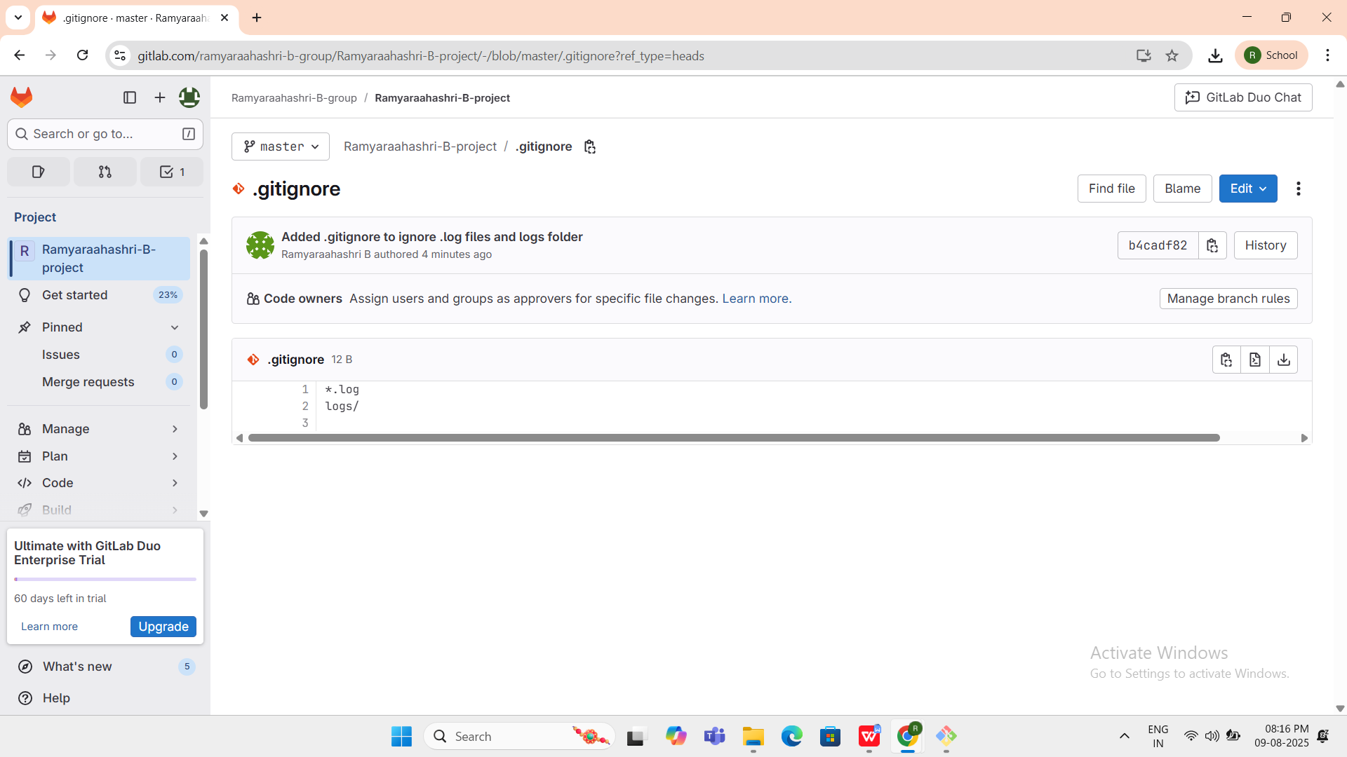

1. Git-HOL

**Deleted the branch after merging with the trunk and observe the git status.**

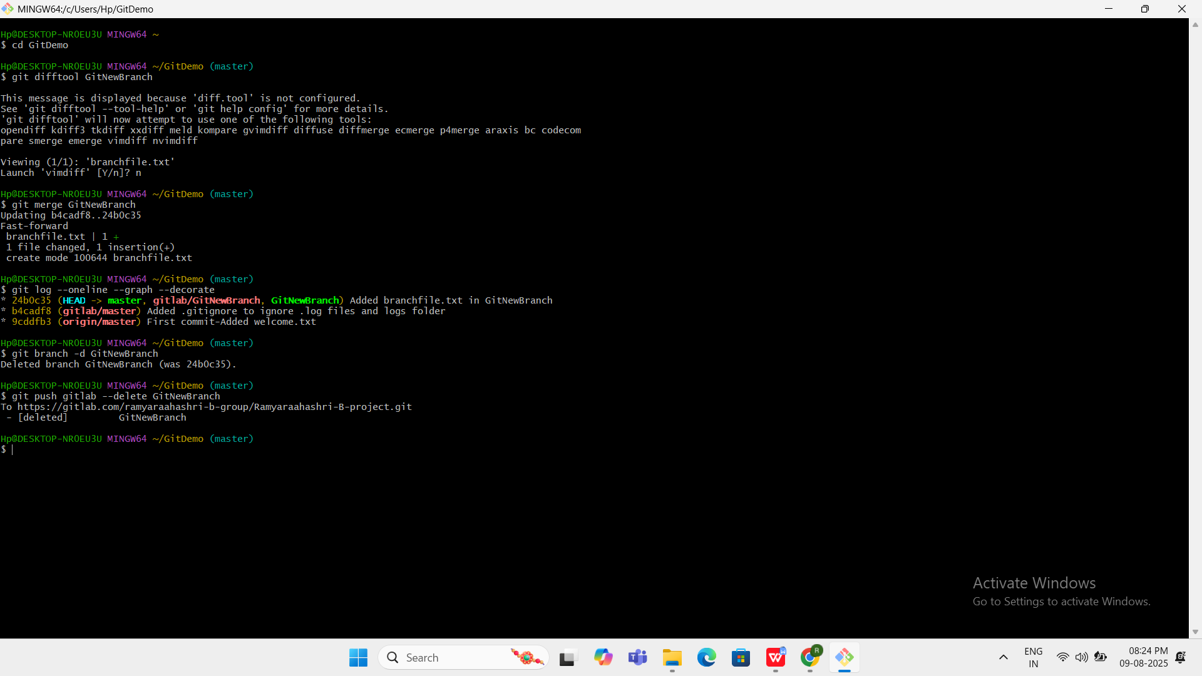

**RESULT:**

$ git push gitlab --delete GitNewBranch

To https://gitlab.com/ramyaraahashri-b-group/Ramyaraahashri-B-project.git

- [deleted] GitNewBranch

1. Git-HOL

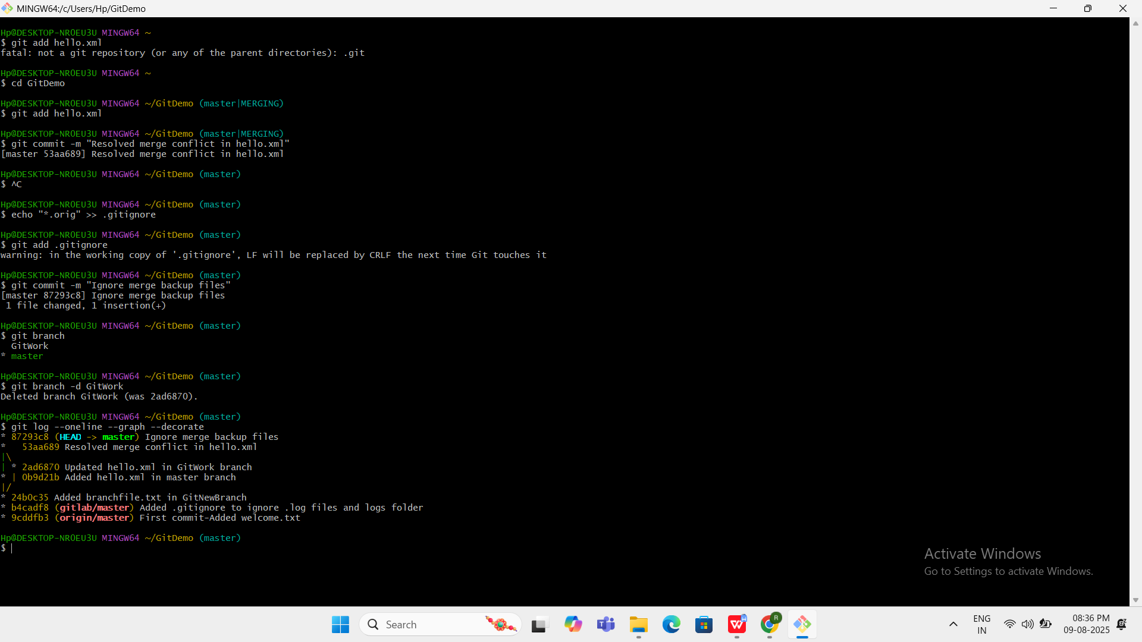

**RESULT:**

Hp@DESKTOP-NR0EU3U MINGW64 ~/GitDemo (master)

$ git branch -d GitWork

Deleted branch GitWork (was 2ad6870).

Hp@DESKTOP-NR0EU3U MINGW64 ~/GitDemo (master)

$ git log --oneline --graph --decorate

* 87293c8 (**HEAD** -> **master**) Ignore merge backup files

* 53aa689 Resolved merge conflict in hello.xml

|\

| * 2ad6870 Updated hello.xml in GitWork branch

* | 0b9d21b Added hello.xml in master branch

|/

* 24b0c35 Added branchfile.txt in GitNewBranch

* b4cadf8 (**gitlab/master**) Added .gitignore to ignore .log files and logs folder

* 9cddfb3 (**origin/master**) First commit-Added welcome.txt

**OUTPUT:**

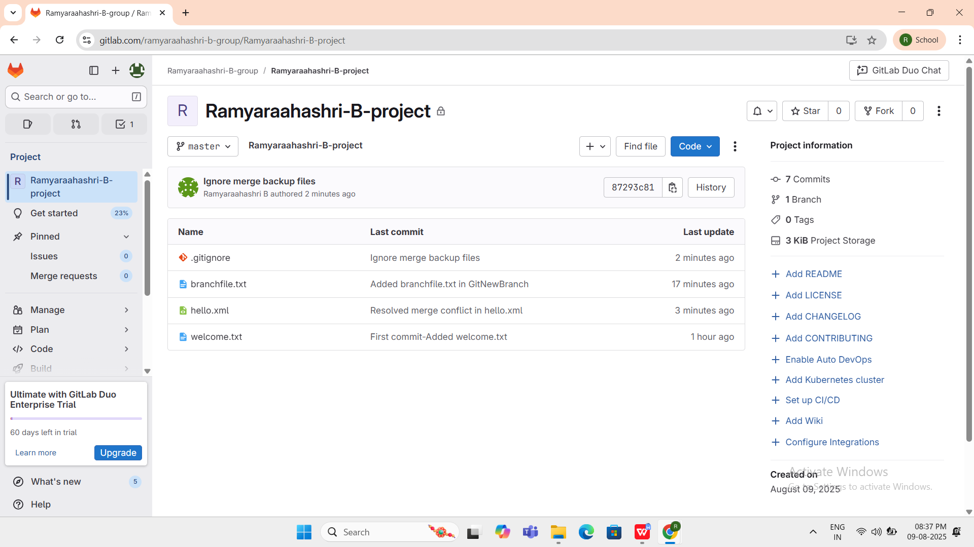

**branchfile.txt**

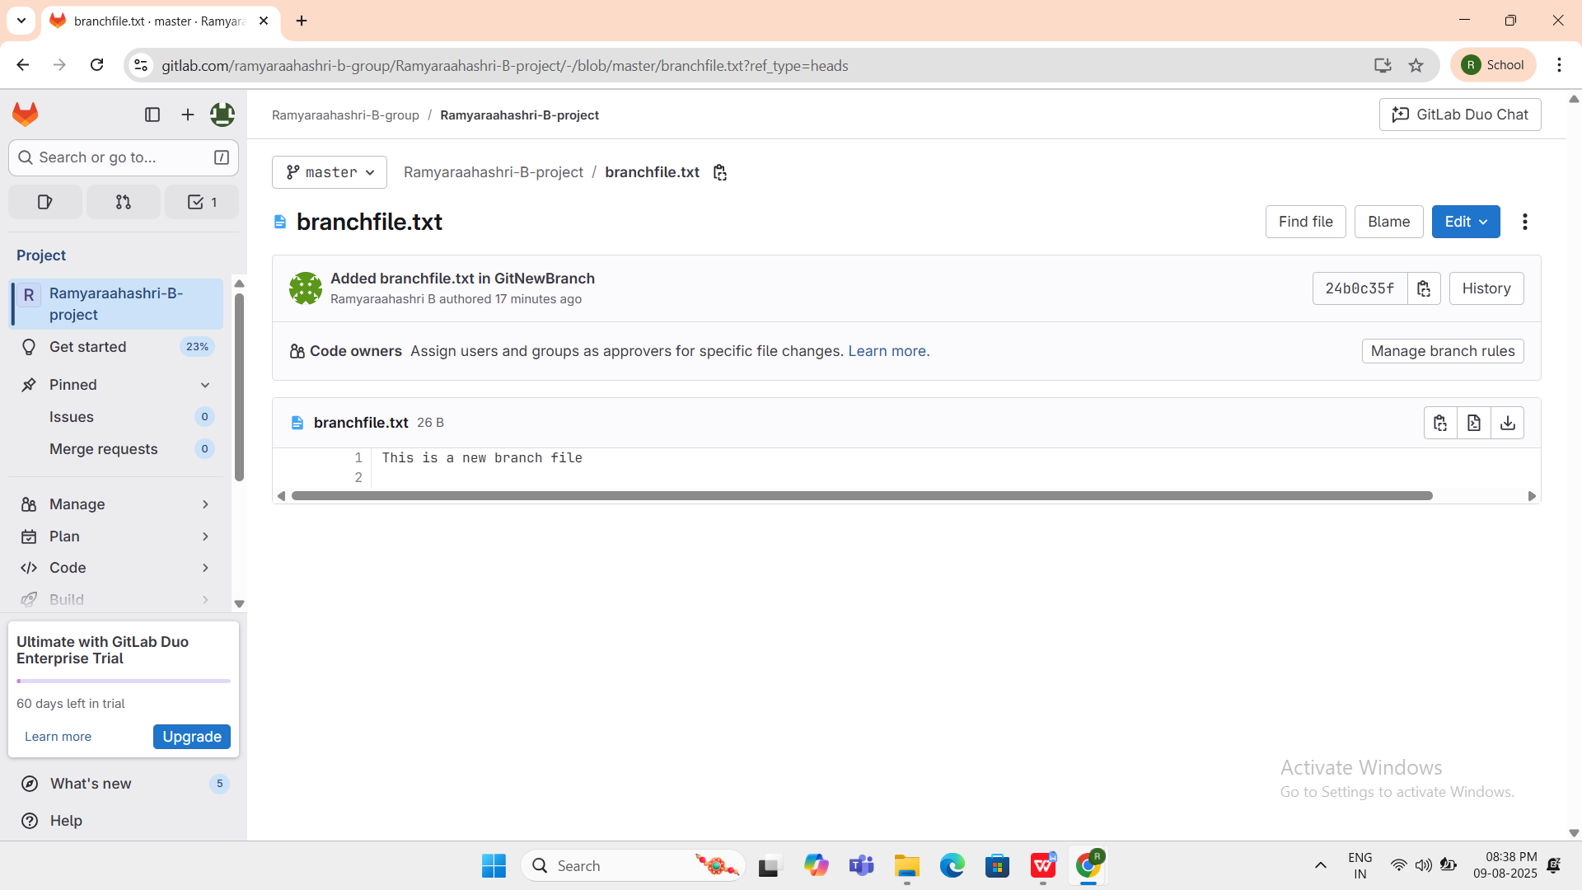

**hello.xml**

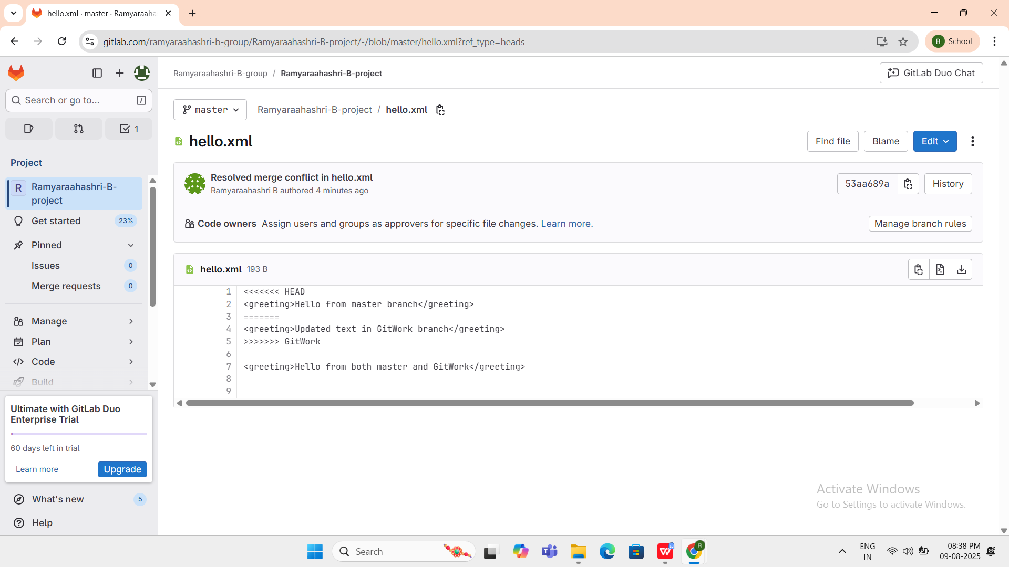

1. Git-HOL

**OUTPUT:**

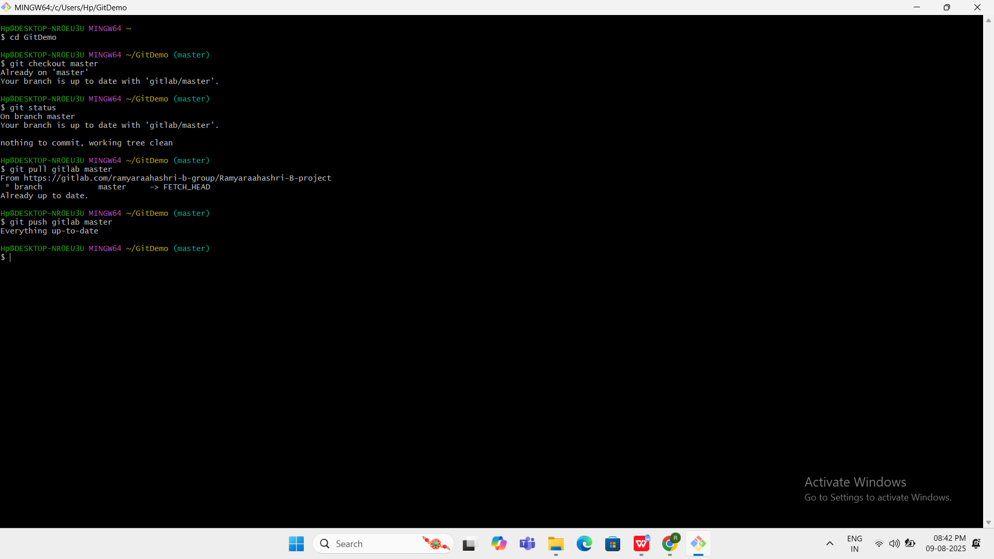

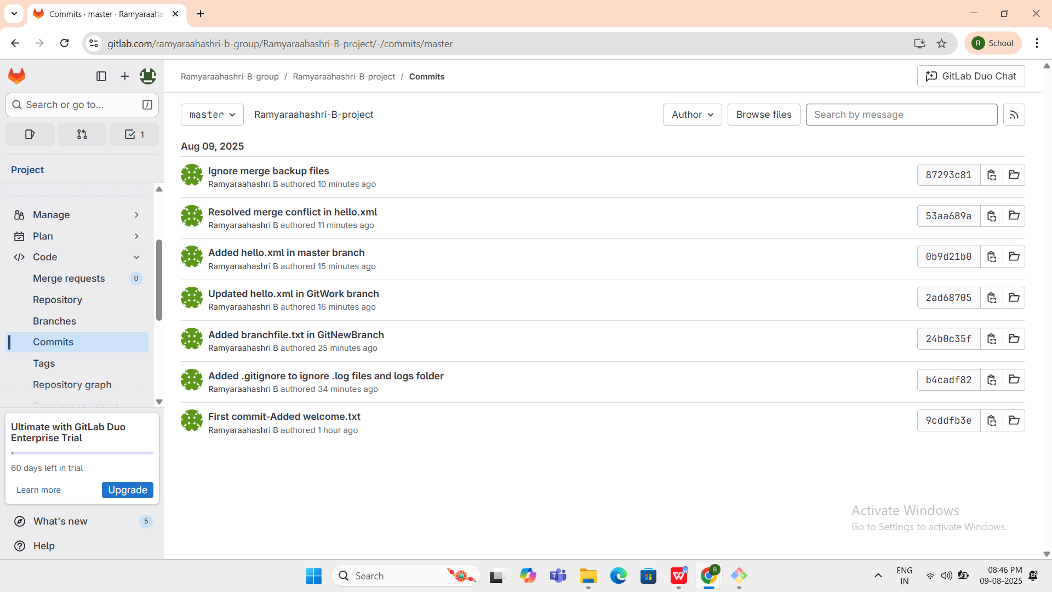

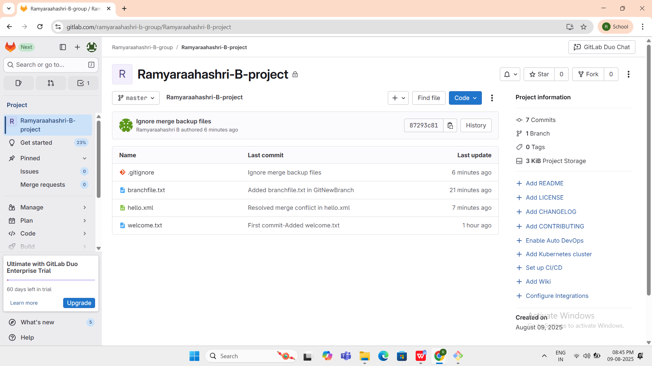

**RESULT:**

Hp@DESKTOP-NR0EU3U MINGW64 ~

$ cd GitDemo

Hp@DESKTOP-NR0EU3U MINGW64 ~/GitDemo (master)

$ git checkout master

Already on 'master'

Your branch is up to date with 'gitlab/master'.

Hp@DESKTOP-NR0EU3U MINGW64 ~/GitDemo (master)

$ git status

On branch master

Your branch is up to date with 'gitlab/master'.

nothing to commit, working tree clean

Hp@DESKTOP-NR0EU3U MINGW64 ~/GitDemo (master)

$ git pull gitlab master

From https://gitlab.com/ramyaraahashri-b-group/Ramyaraahashri-B-project

* branch master -> FETCH_HEAD

Already up to date.

Hp@DESKTOP-NR0EU3U MINGW64 ~/GitDemo (master)

$ git push gitlab master

Everything up-to-date

Hp@DESKTOP-NR0EU3U MINGW64 ~/GitDemo (master)

$ git status

On branch master

Your branch is up to date with 'gitlab/master'.

nothing to commit, working tree clean